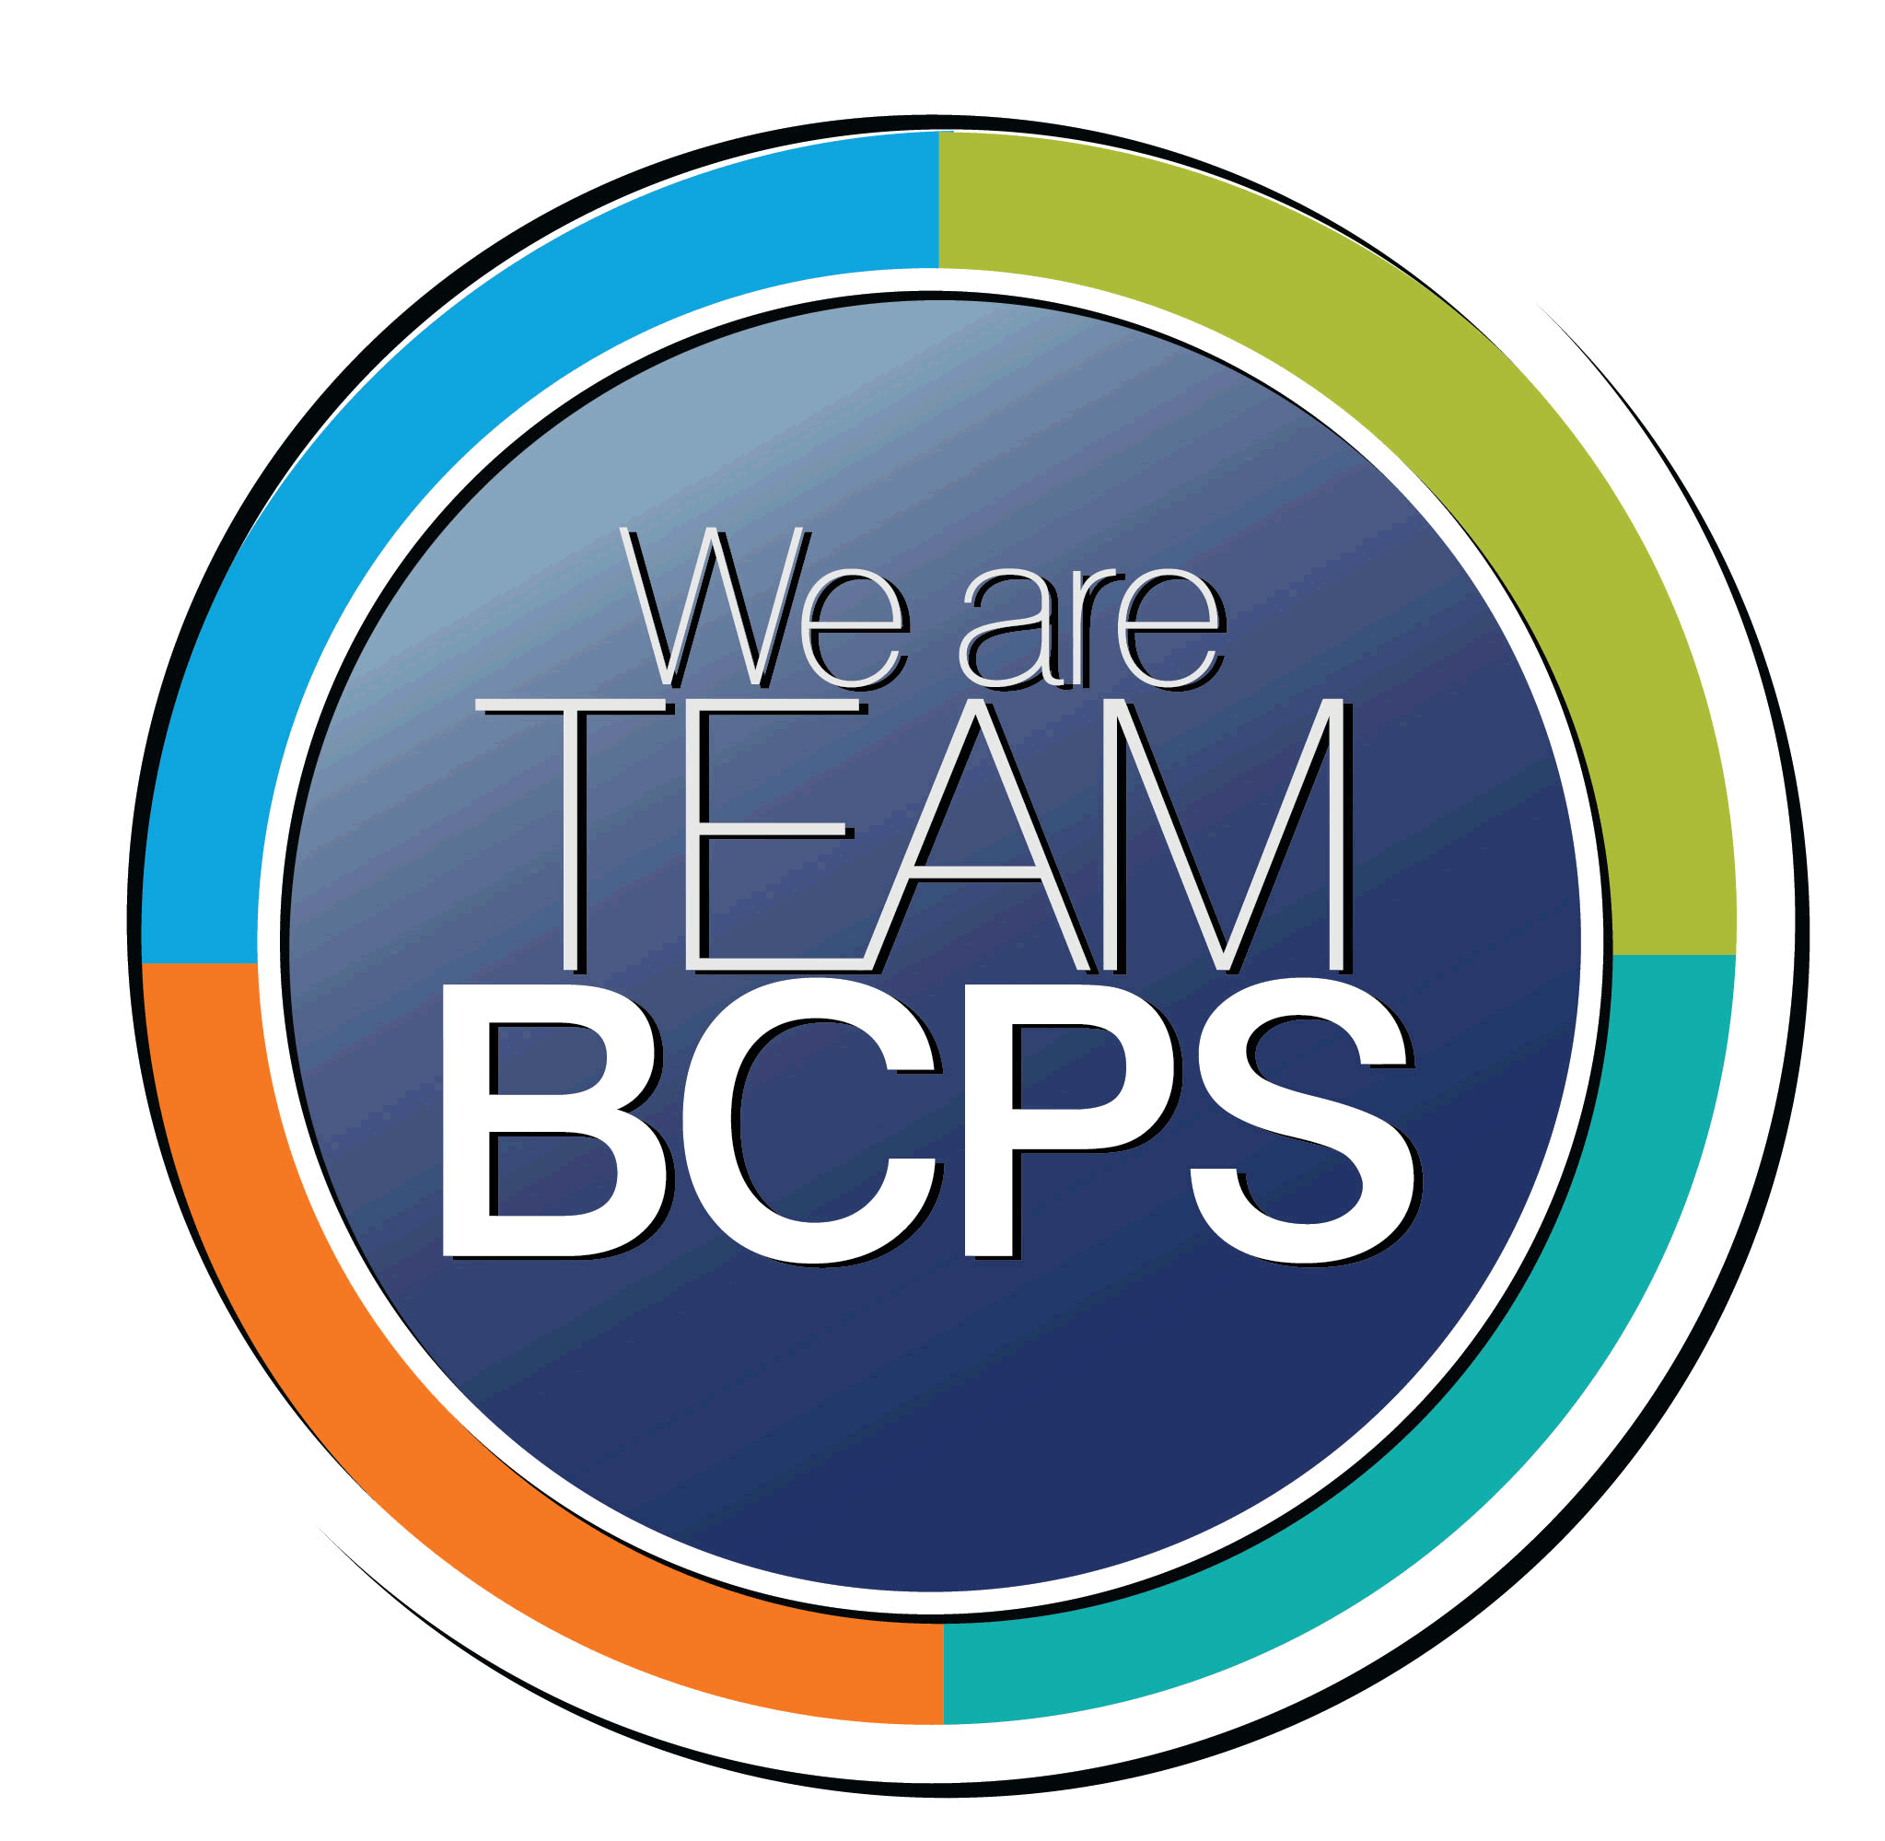 **Schoolwide Positive Behavior Plan** 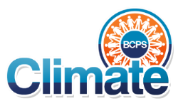

**Baltimore County Public Schools**

**Date Completed: 8/2/2021 School Year 2021-2022**

**School: Golden Ring Middle School**

|  |
| --- |
| **Section 1: Initial Steps** |
|  |
| **School Climate Team** |
| *Identify members of a School Climate Team (consider a representative selection of members). The team meets initially to examine equity concerns and data and to develop the Schoolwide Positive Behavior Plan. The team should then meet monthly (minimum quarterly) to assess the effectiveness of the SWPBP on an ongoing basis.* |
| Charlyne Maul, Principal  Terrence Robinson, Assistant Principal  David Glover, Guidance  Tiffany Grosso, Math DC  Elizabeth Ledl, Math Resource, GLM gr 7  Kay Antley, GLM gr 6  Kathryn Wilson, GLM gr 6  Erin Stokes, GLM gr 7  Eric Lindsey, GLm gr 8  Marcia Jones, MTSS  Megan Isbell, PPW |
| **Equity Lens** |
| *Through an equity lens, identify what the data indicate about the social-emotional needs of students and the support provided by staff members relative to disproportionality between student groups, especially for African Americans or students receiving special education. Also consider the school’s population with regard to ELL, Latinx, and/or other student groups. (Information may be from School Data Story)* |
| Black/African American students are suspended at rates higher than their non-Black/African American peers. The suspension rate gap for Black/African American students at Golden Ring Middle is greater than the same gap for all BCPS middle schools. This gap has narrowed over time, indicating a positive trend.  • Two or More Races students are suspended at rates higher than their non-Two or More Races peers. The suspension rate gap for Two or More Races students at Golden Ring Middle is less than the same gap for all BCPS middle schools. This gap has narrowed over time, indicating a positive trend.  • Students eligible for FARMS are suspended at rates higher than their non-FARMS peers. The suspension rate gap for students eligible for FARMS at Golden Ring Middle is less than the same gap for all BCPS middle schools. This gap has narrowed over time, indicating a positive trend.  • Students eligible for Special Education are suspended at rates higher than their non-Special Education peers. The suspension rate gap for students eligible for Special Education at Golden Ring Middle is less than the same gap for all BCPS middle schools. This gap has widened over time, indicating a negative trend. |
| **Data Analysis** |
| *Summarize what the data tell about the school climate. (Information from School Data Story)* |
| Focus needed on African American/Black students and Special Education students. |
| **Climate Goals** |
| *Identify the school’s goals in improving the social-emotional climate of the building. (Information from School Progress Plan)* |
| Educators will examine and interrogate their personal biases to become aware of the ways in which their own cultural experiences influence the conditions and learning opportunities that they create for students.  We will develop a comprehensive Mentoring program to address inequity issues related to attendance, discipline, and achievement for identified, underserved student groups.  Teachers will consider student voice and advocacy in instructional decision making by implementing the essential components of SEL and Restorative Practices in order to teach social/emotional competencies. |
| **Section 2: Developing and Teaching Expectations** |
|  |
| **Expectations Defined** |
| *Identify a School Code of Conduct with 3-5 positively stated school expectations. Develop a way to communicate the identified rules, based on the schoolwide expectations, for specific settings within the school building. Expectations should be clearly stated, communicated, taught, and frequently referenced.* |
| As a member of the Golden Ring MS community, I will:  **P**repare for my future  **R**espect myself and others  **I**nvest in my own learning  **D**emonstrtare respesnible decision making  **E**xhibit PANTHER PRIDE every day in every way! |
| **Classroom Plan for Teaching and Reinforcing Expectations, Routines, and Procedures** |
| *Teachers develop visuals to communicate culturally relevant classroom expectations, routines, and procedures based upon the schoolwide expectations. Educators explicitly teach expectations, routines, and procedures. The school staff recognize and reinforce expected and positive behavior. Teachers identify encouraging procedures and corrective procedures for their classrooms.* |
| As a member of the Golden Ring MS community, I will:  **P**repare for my future  **R**espect myself and others  **I**nvest in my own learning  **D**emonstrtare respesnible decision making  **E**xhibit PANTHER PRIDE every day in every way! |
| **Family/Community Engagement** |
| *Identify how the Schoolwide Positive Behavior Plan, the schoolwide expectations, and/or interventions will be communicated and shared with families. Consider how to include family and student voice in the initial plan and in evaluating the plan throughout the year.* |
| Communicated at BTSN,  Communicated in summer mailing  Add 3 students and 3 parents to the team in September. |
| **Section 3: Developing Interventions and Supporting Students** |
|  |
| **Resource Mapping of MTSS** |
| *Identify the evidence-based practices and interventions offered at Tier 1, Tier 2, and Tier 3 to support all students. Consider what culturally responsive interventions the school requires to meet the specific needs of the students.* |
| Tier 1  Panther PRIDE and token economy system  Tier 2  GLM and MTSS referrals  Second Step program lessons  Tier 3  Mentoring program  Weekly monitoring of progress |
| **Social-Emotional Learning** |
| *Identify the specific evidence-based social-emotional learning skill development practices the school will implement during the school year. Consider the importance of trauma-informed care, mental health awareness, level of students’ coping skills, etc. Determine how the social-emotional learning and the SEL competencies will be integrated into the school’s programming. Consider the need for any training the staff members may require.* |
| Restorative practices  Questions used by teachers  Circles in Homeroom and classes |
| **Character Education** |
| *Determine how specific evidence-based character education learning will be infused into the school’s programming to promote positive behavior and ethical decision-making. Character education will be culturally responsive and co-created with diverse stakeholders. Consider the need for any training the staff members may require.* |
| Health Science Professionals trait of the month and Student of the Month awards |
| **Professional Development for Staff** |
| *Identify the professional development that will be offered to staff members throughout the year in order to support their knowledge, skill development, and implementation of the interventions selected, the character education learning, and social-emotional learning practices. Specify the schedule for professional development and how to obtain teacher feedback during the year to address their concerns and areas in which they want/need more information. (Information from School Progress Plan.)* |
| Scaffolded and Tiered PD for New teachers, struggling teachers and expert teachers. |
| **Section 4: Supporting and Responding to Student Behavior** |
|  |
| **Recognitions/Incentives** |
| *Identify a variety of positive consequences, acknowledgements, recognitions, and/or incentives that are linked to the behavioral expectations and rules. Develop a system for implementing the positive acknowledgements consistently in school settings. Consider how to monitor who is being recognized and who is not being recognized and whether explicit or implicit biases may be occurring.* |
| Student of the Month  Honor Roll  Principal’s List  Quarterly Town Hall Meetings  Token Economy rewards |
| **Hierarchy for Behavioral Referrals and Consequences** |
| *Identify the behaviors that are teacher-managed, behaviors referred to resource staff, and behaviors referred to administration. Refer to the BCPS Student Handbook for teacher and administrator-led interventions. Consider how unsafe behaviors will be addressed.* |
| **Teacher Managed Behaviors**   * Inappropriate language * Defiance/Non-compliance * Disruption * Property (non-technology) abuse * Technology (device/phone) abuse * Truancy/Lateness * Academic dishonesty |
| **Response for Intensive Behaviors** |
| *Identify a hierarchy of responses to intensive behaviors (i.e., emergency/crisis management/threat assessment/unsafe behaviors) including interventions and supports. Indicate which school staff members will respond as well as procedures and training as needed.* |
| **Administrator Managed Behaviors**   * Physical aggression/fighting * Bullying/harassment * Drugs/alcohol * Vandalism * Weapons * Any category II or III offense |
| **Monitoring the Schoolwide Positive Behavior Plan/Data Analysis** |
| *Identify the data that will be collected and reviewed by the School Climate Team in order to identify behavior trends, patterns, action steps, and interventions using a problem-solving strategy. Consider having a uniform referral form for staff to complete to document referrals to administration. Consider how teachers should document classroom-managed concerns/behaviors/difficulties. (Information from School Progress Plan.)* |
| GLM referrals  MTSS referrals  Office referrals |
| **Section 5: Miscellaneous Content/Components** |
| Restorative practices |